**NETWORK – CSC329**

**Mid-1 Questions**

1. **Define the concept of layer in communication architecture?**

* Set of tasks implement separately to process data during communication.

1. **Define the concept of protocol?**

* **Protocol** Is a set of rules that governs the exchange of data between two entities of the network.

1. **Name the seven layers defined in the ISO OSI Reference Model and state the functions of the lowest three layers?**

* Layer 7: Application.
* Layer 6: Presentation
* Layer 5: Session
* Layer 4: Transport
* Layer 3: Network – is responsible for delivers of individual packets from source host to destination host.
* Layer 2: Data link – is responsible of movements of frames from one hop to the next
* Layer 1: Physical – is responsible of movements of bits from one hop to the next

1. **Give the Shannon’s theorem that describes the data rate of a physical medium with respect to signal to noise ratio?**
2. **Calculate theoretical highest bit rate of a regular telephone line that has a bandwidth of 3000 hz. The signal to noise is 3162.**

* C = B log2 ( 1 + SNR ) = 3000 log2 ( 1 + 3162 ) = 3000 log2 3162

= 3000 * 11.62 = 34,860 bps

1. **Explain the concept of bit staffing in bit-oriented synchronous transmission.**

Stuffing done at the bit level:

* Frame flag has six consecutive 1s (01111110)
* On transmit, after five 1s in the data, a 0 is added
* On receive, a 0 after five 1s is deleted

1. **Suppose the following bit string is received by the data link layer from the network layer: 01110111101111101111110. What is the resulting string after bit stuffing process?**

* 01110111101111111111010

1. **A sender (S) wants to send a message M = 1010001101. It uses the CRC method to generate the frame check sequence FCS.**

**The used generator polynomial is given by G(x) = X5 + X4 + X2 + 1.**

* + - 1. **Give the polynomial M(x) that represent the message M.**
      * M(x) = X9 + X7 + X3 + X2 + 1
      1. **Determine the sequence of bits ( 5 bits ) that allows detecting errors.**
      2. **Represent the binary whole message (T) send by the sender (S).**
      3. **How does the receiver check whether the message T was transmitted without any errors?**

1. **Briefly explain the difference between transmission time and propagation time.**

* **Transmission time:** time to put M-bit message “on the wire”.
* **Transmission time =** M (bit) / rate (bit/sec) = M/R seconds
* **Propagation time:** time for bits to propagate across the wire.
* **propagation time =** length / speed of signals = D seconds.

1. **Assume that two hosts, A and B are connected by a single link with rate R bps (bits per seconds). A and B are separated by m meters and the propagation speed along the link connecting them is s meters/seconds. Host A is sending a packet of L bits to host B. Ignoring processing and queuing time, obtain an expression for the end-to-end delay.**

* Latency = M/R+D

1. **We consider the sliding window protocol figure 2. Does this figure indicate that Go-Back-N is being used or selective repeat is being used?**

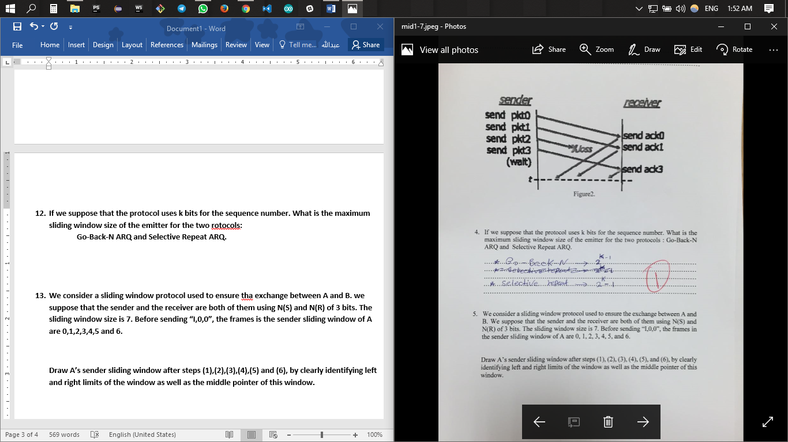

1. **If we suppose that the protocol uses k bits for the sequence number. What is the maximum sliding window size of the emitter for the two rotocols:**

**Go-Back-N ARQ and Selective Repeat ARQ.**

1. **We consider a sliding window protocol used to ensure tha exchange between A and B. we suppose that the sender and the receiver are both of them using N(S) and N(R) of 3 bits. The sliding window size is 7. Before sending “I,0,0”, the frames is the sender sliding window of A are 0,1,2,3,4,5 and 6.**

**Draw A’s sender sliding window after steps (1),(2),(3),(4),(5) and (6), by clearly identifying left and right limits of the window as well as the middle pointer of this window.**

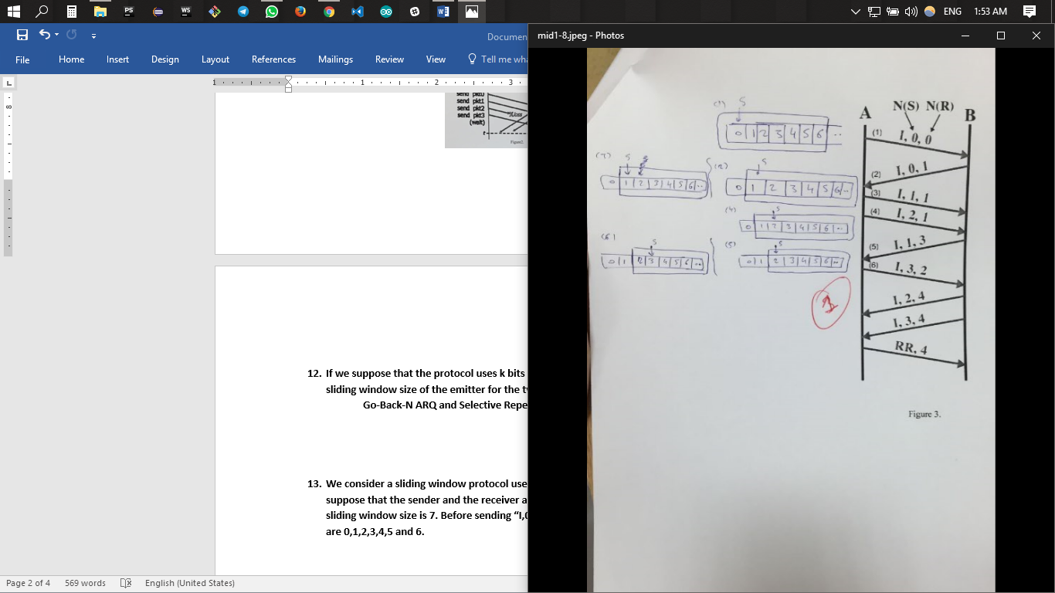

**Mid-2 Questions**

1. **Explain csma.**

* A node should not send if another node already sending.
* Inverted the minimize collisions.

1. **Explain slotted aloha.**

* Time is divide to equal size slots.
* Frames are of the same size.

1. **Explain the difference between csma and slotted aloha.**

* CSMA is less collision than slotted aloha.
* Slotted aloha use generate random number to repeat send.
* Aloha protocol does not try to detect whether the channel is free before transmitting.
* CSMA protocol verifies that the channel is free before transmitting data.

1. **Explain the difference between the inter-frames in IEEE.**

* SIFS : highest priority, for ACK, CTS, polling response.
* PIFS : medium priority, for time-bounded service using PCF.
* DIFS : lowest priority, for asynchronous data service.

1. **Explain the concept of sliding window.**

* Sequence numbers
* Sent frames are numbered sequentially
* Sequence number is stored in the header
* to hold the unacknowledged outstanding frames
* In Go-back-N ARQ the receiver window size always 1

1. **Explain the period contention in csma-ca.**

* Used by all carrier sense variants.
* Provides random access to the channel.

1. **Explain the difference between Go-Back-N and selective repeat.**

* **GO-BACK-N**
  + Retransmits all the frames that sent after the frame which suspects to be damaged or lost.
* **Selective Repeat:**
  + Retransmits only those frames that are suspected to lost or damaged.

**Final Questions**

1. **Why the RTS and CTS are not used in CSMA/CD?**

Because of hidden node problem in CSMA/CD -“occurs when a node is visible from a access point (AP), but not from other nodes communicating with that AP"

**Because wireless is more complicated than wired. In wireless we cannot detect collisions so we have to avoid them!**

1. **Explain with a diagram how the CSMA/CA uses different inter frame between the frames?**

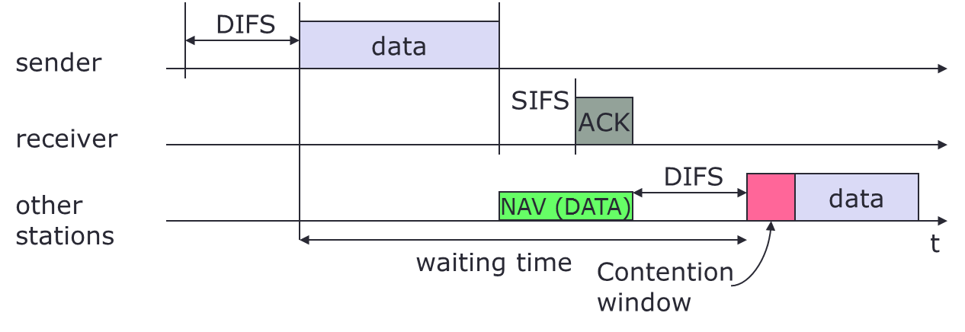

* + station has to wait for DIFS before sending data
  + receiver acknowledges at once (after waiting for SIFS) if the packet was received correctly (CRC)
  + automatic retransmission of data packets in case of transmission errors

**eathernet protocol uses CSMA/CD for multiple access control when collision is detected. How does the eathernet back-off to avoid future collision CSMA/CD.**

detecting voltage level on the line

detecting power level

detecting simultaneous transmission & reception

**use this figure to explain the concept of hidden node problem is wireless communication**

**Use diagram below to explain how CSMA/CA is realized in the case of the IEEE 802.11 protocol. For your explanation, assume that A wants to send a frame to the destination.**

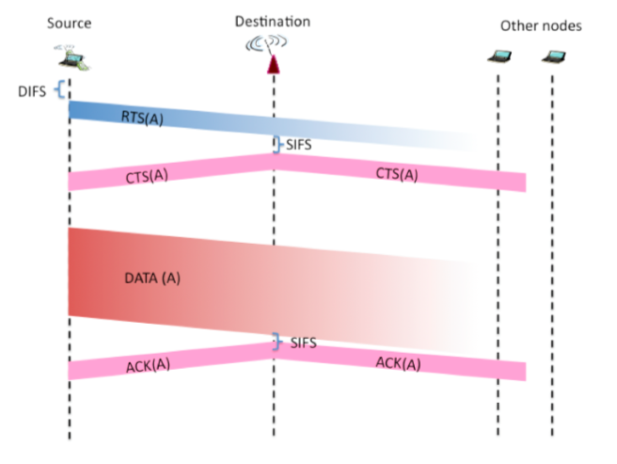

**why are ACK used in 802.11 but not in wired Ethernet**

*Usually no packet loss in wired Ethernet. This is much more likely in a wireless scenario. Robustness is increased through retransmissions. To be able to perform retransmissions ACKs are required.*

**Use the figure below to explain the “hidden node” problem. What happens   
when nodes A and C start sending a message simultaneously?**

هذا حق الثلاث دوائر

cannot detect a transmission from C and vice versa. If A and C start sending simultaneously to B a collision at B will happen but A and C will not become aware of the collision